PROJECT PLANNING PHASE
Project Planning Template (Product Backlog, Sprint Planning, Stories, Story Points)
Date | 06 October 2026
Project Name | Medical Diagnosis Center by ServiceNow Service Portal
Maximum Marks | 5 Marks
Product Backlog, Sprint Schedule, and Estimation
Sprint | Functional Requirement (Epic) | User Story Number | User Story / Task | Story Points | Priority
Sprint-1 | Medical Test Catalog & Booking | MDC-1 | Configure Medical Test Catalog and diagnostic-test selection | 3 | High
Sprint-1 | Medical Test Catalog & Booking | MDC-2 | Configure Book Now and Patient Details fields | 3 | High
Sprint-1 | Medical Test Catalog & Booking | MDC-3 | Configure patient-detail validation and dynamic form behaviour | 3 | High
Sprint-2 | Schedule, Payment & Appointment | MDC-4 | Configure Schedule and appointment date/time handling | 5 | High
Sprint-2 | Schedule, Payment & Appointment | MDC-5 | Configure the Payment → Done booking stage | 5 | High
Sprint-2 | Schedule, Payment & Appointment | MDC-6 | Create and map the Appointment record | 3 | High
Sprint-2 | Schedule, Payment & Appointment | MDC-7 | Configure appointment lifecycle and status context | 2 | Medium
Sprint-3 | My Appointments, Completion & Reports | MDC-8 | Configure My Appointments visibility and status behaviour | 3 | High
Sprint-3 | My Appointments, Completion & Reports | MDC-9 | Configure Appointment Completed and report-generation trigger | 3 | High
Sprint-3 | My Appointments, Completion & Reports | MDC-10 | Configure automatic Report creation and My Lab Reports visibility | 3 | High
Sprint-3 | My Appointments, Completion & Reports | MDC-11 | Validate diagnostic appointment-to-report handoff and lifecycle stages | 4 | High
Sprint-4 | Testing, Security & Deployment | MDC-12 | Test diagnostic-test selection, patient data and mappings | 3 | High
Sprint-4 | Testing, Security & Deployment | MDC-13 | Use Flow Execution Details to debug workflow and condition failures | 2 | Medium
Sprint-4 | Testing, Security & Deployment | MDC-14 | Perform end-to-end booking, appointment, completion and report testing | 3 | High
Sprint-4 | Testing, Security & Deployment | MDC-15 | Perform UAT and role/security testing | 3 | High
Sprint-4 | Testing, Security & Deployment | MDC-16 | Prepare deployment / recreation documentation for a new PDI | 5 | High
Project Tracker, Velocity & Burndown Chart
Sprint | Total Story Points | Duration | Sprint Start | Sprint End (Planned) | Story Points Completed | Release Status
Sprint-1 | 9 | 5 Days | Day 1 | Day 5 | 9 | Completed
Sprint-2 | 15 | 5 Days | Day 6 | Day 10 | 15 | Completed
Sprint-3 | 13 | 5 Days | Day 11 | Day 15 | 13 | Completed
Sprint-4 | 16 | 5 Days | Day 16 | Day 20 | 16 | Completed
Velocity: Total completed story points = 53. Number of sprints = 4. Average team velocity = 53 / 4 = 13.25 story points per sprint.
Burndown Chart
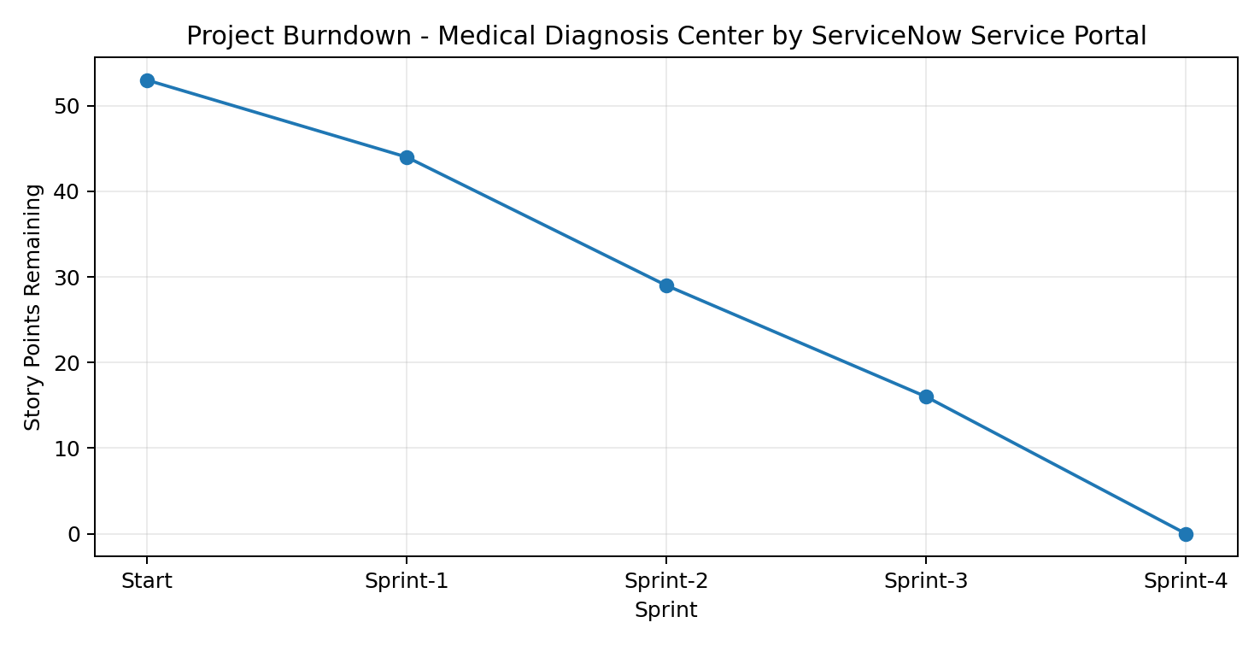
Figure 1. Remaining story points after each completed sprint.
The burndown chart uses the same relative 20-day schedule as the planning template: four 5-day sprints. It represents remaining story points after each sprint and does not claim exact historical calendar dates.
Sprint Release Summary
Sprint | Release Outcome
Sprint-1 | Medical/healthcare service catalog item, patient/requester variables, Requester Information variable set, and dynamic form behaviour completed.
Sprint-2 | Flow Designer automation, catalog-variable retrieval, healthcare-service operational record mapping, appointment/approval processing, and REQ/RITM request context completed.
Sprint-3 | Request notifications, ACL security, appointment/approval relationship, operational visibility, and diagnostic/service fulfilment lifecycle handoff completed.
Sprint-4 | Variable/mapping tests, Flow Execution debugging, end-to-end workflow testing, UAT/security testing, and deployment/recreation documentation completed.
Planning Note: Exact historical sprint dates and individual team-member assignments were not supplied in the source material. The tracker therefore uses a relative 20-day schedule (four 5-day sprints), while preserving the sprint sequence, backlog structure, story-point estimation, and completed-work format of the reference.

